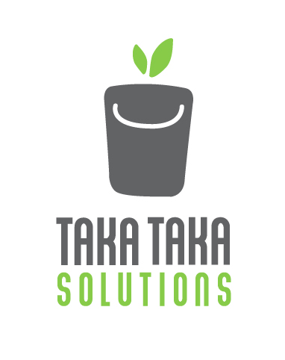

Proposal to Nyari Residents Welfare Association

November 2014, Nairobi

__________________________________________________________________

TakaTaka Solutions

Southern Bypass, off Ngong Road

P.O. Box 29273

00625 Nairobi – Kenya

**About TakaTaka Solutions**

Waste management is a major challenge in Nairobi. The public sector struggles to run an effective and efficient waste management system due to poor planning and lack of finances. Private sector waste collection companies only collect waste to dispose it at badly managed dumpsites. This neglects the potential value of waste. As a consequence, waste management becomes so expensive that 66% of Nairobi’s inhabitants (2.5 million people) cannot afford it. These are mainly people living in lower income areas. Uncollected waste causes severe health and environmental problems.

**TakaTaka Solutions***is a social enterprise committed to address this challenge* (“takataka” means waste in Kiswahili). By offering an innovative socially-driven business approach it aims to bring aboutsocio-economic and environmental change:

* Affordable waste collection services to all income areas
* Recycling and composting of 80% and more of collected waste
* Formal job creation for youths from lower income areas
* A cleaner and healthier environment
* 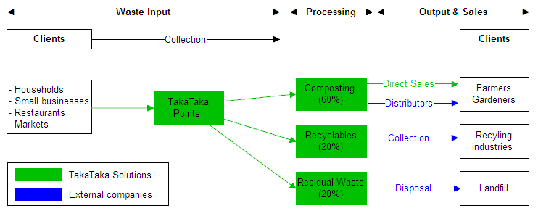Provision of high quality waste-to-value products

To implement its model, TakaTaka Solutions operates various recycling points (TakaTaka Points), trucks as well as a composting and recycling facility.

**Project undertaken with Runda Resident Association**

TakaTaka Solutions recently started working with the Runda Resident Association as to help Runda in its goal to become greener estate. Prior to starting services, the following challenges were analysed:

* **Lack of ‘green’ waste management and recycling**: Almost all of the waste currently collected was disposed at Dandora dumpsite
* **Offering jobs to youths from low-income areas**: Residents wanted to create jobs for the youths of the neighbouring low-income areas of Githogoro and Huruma.
* **Reliability of current collection service**: Waste collection services were frequently unpunctual and left behind waste

Subsequent to this, TakaTaka Solutions started implementing the following waste management services within Runda Estate from October 2014 onwards:

* Three times a week timely waste collection
* 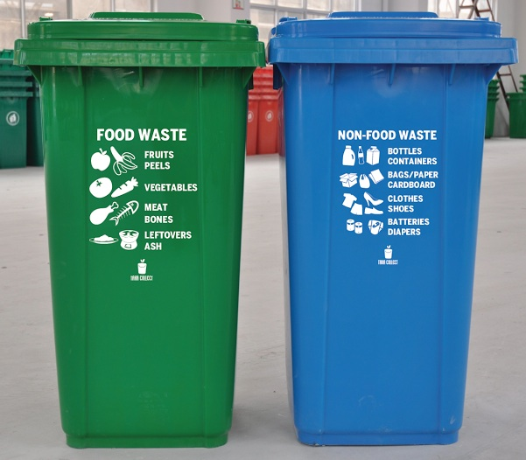**Waste separation at source** through provision of two bags to houses (organic and recyclables)
* **Recycling of waste** at TakaTaka Solutions nearby recycling point 🡪**80% to 90% recycling rate**
* **Employment of local youths** in collection and recycling point
* Waste separation training to Runda residents and staff
* Providing of **high-quality bins** to Runda residents

From January 2014 TakaTaka Solutions will also offer the following add-on services to Runda residents:

* **Collection of garden waste**: TakaTaka Solutions will manage the collection and composting of all garden waste in Runda.
* **Collection of waste in neighbouring low-income areas**: TakaTaka Solutions will start collecting waste in the low-income areas of Githogora and Huruma. This will be done with support of Runda Water.
* 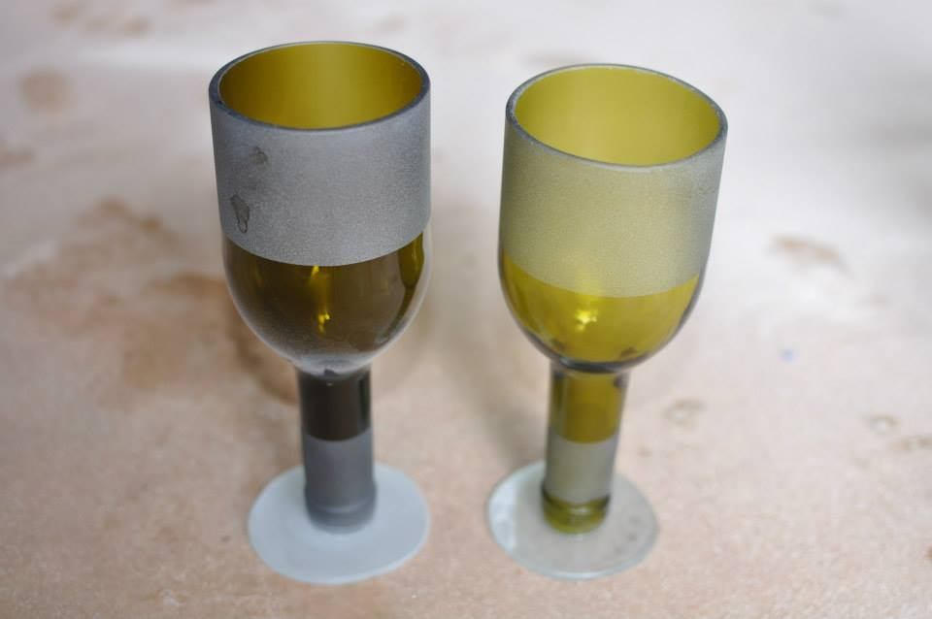**Selling back of recycled products:** TakaTaka Solutions will offer to sell high quality products made from recycled materials to Runda residents: Compost and glasses.

**Proposal to Nyari Residents Welfare Association**

TakaTaka Solutions would like to offer similar waste management services to Nyari residents:

* Timely household waste collection
* 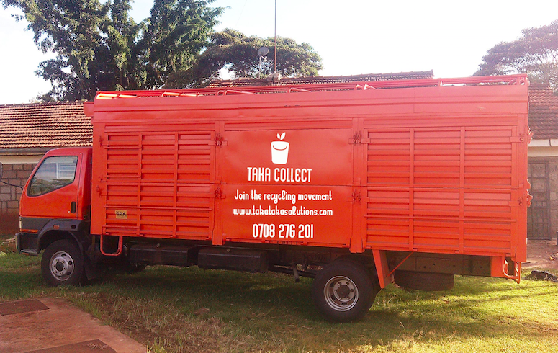Waste separation at source through provision of two bags to houses (organic and recyclables)
* Recycling of waste at TakaTaka Solutions nearby recycling point 🡪80% to 90% recycling rate
* Employment of local youths in collection and recycling point. All employees receive fair wages and proper safety equipment. They also have a health insurance for themselves and their families and are part of a savings cooperative.
* Waste separation training to Nyari residents and staff
* Providing of high-quality bins to Nyari residents
* Collection of garden waste

In case of interest, TakaTaka Solutions can also:

* Offer waste collection services to neighboring low-income areas with the support of Nyari Residents Welfare Association
* Sell back recycled products to Nyari residents (glasses & compost)